Advocacy support

- POhWER support centre can be contacted via 0300 456 2370
- Advocacy People gives advocacy support on 0330 440 9000
- Age UK on 0800 055 6112
- Local Council can give advice on local advocacy services

Further action
If you are dissatisfied with the outcome of your complaint from either NHS England or this organisation then you can escalate your complaint to Parliamentary Health Service Ombudsman (PHSO) at either:
Milbank Tower, Milbank LONDON
SW1P 4QP

Citygate, Mosley Street MANCHESTER
M2 3HQ
Tel: 0345 015 4033
www.ombudsman.org.uk

The Complaints Process

The University of Nottingham Health Service
Cripps Health Centre
University Park
Nottingham
NG7 2QW.

0115 8468888 / nnicb- nn.c84023@nhs.net

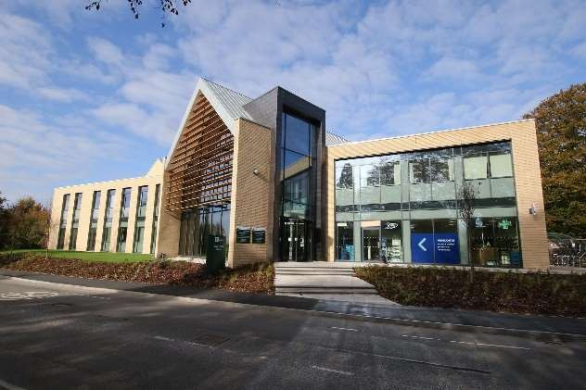

Talk to us
Every patient has the right to make a complaint about the treatment or care they have received at UNHS.
We understand that we may not always get everything right and, by telling us about the problem you have encountered, we will be able to improve our services and patient experience.

Who to talk to
Most complaints can be resolved at a local level. Please speak to a member of staff if you have a complaint; our staff are trained to handle complaints. Alternatively, ask to speak to the complaint’s manager, the Chief Operating Officer or the Practice Manager.
A complaint can be made verbally or in writing. A complaints form is available from reception. Additionally, you can complain via email to nnicb-nn.c84023@nhs.net.

If for any reason you do not want to speak to a member of our staff, then you can request that Nottingham and Nottinghamshire ICB investigates your complaint. They will contact us on your behalf:
Patient Experience Team
Civic Centre
Arnot Hill Park
Nottingham Road
Arnold
Nottingham
NG5 6LU
Email: nnicb.nn.patientexperience@nhs.net

Time frames for complaints
The time constraint on bringing a complaint is 12 months from the occurrence giving rise to the complaint, or 12 months from the time you become aware of the matter about which you wish to complain.
The complaints manager will respond to all complaints within three business days.
We will aim to investigate and provide you with the findings as soon as we can and will provide regular updates regarding the investigation of your complaint

Investigating complaints
UNHS will investigate all complaints effectively and in conjunction with extant legislation and guidance.

Confidentiality
UNHS will ensure that all complaints are investigated with the utmost confidentiality and that any documents are held separately from the patient’s healthcare record.

Third party complaints
UNHS allows a third party to make a complaint on behalf of a patient. The patient must provide consent for them to do so. A third-party patient complaint form is available from reception.

Final response
UNHS will issue a final formal response to all complainants which will provide full details and the outcome of the complaint. We will liaise with you about the progress of any complaint.

